

**Feedback and Feedforward for Learning Policy**

**A policy on feedback that helps to instil:**

**Independence. Communication. Creativity. Risk-taking. Curiosity. Resilience.**

**Reviewed June 2024 Heidi Berry**

**Aspire for Excellence**

Every teacher will know whether they are getting useful information from their ''marking'' and whether pupils are progressing.

This Feedback and Feedforward for Learning Policy allows our teachers to ensure that maximum learner progress is taking place at all times. We seek a common-sense approach, that considers teacher workload, and aims to ensure that a teacher's comments motivate and means something to the learners.

Marking should serve a single purpose – to advance pupil progress and outcomes. Teachers should be clear about what they are trying to achieve and the best way of achieving it. (*Eliminating unnecessary workload around marking Report of the Independent Teacher Workload Review Group March 2016*)

Taken from *The Education Endowment Foundation, Teacher Feedback to Improve Pupil Learning,* (Oct 2021), <https://educationendowmentfoundation.org.uk/education-evidence/guidance-reports/feedback> , and their six recommendations for using teacher feedback to improve pupil learning, the chart below summarises their findings and forms the principles of what our policy is based upon:

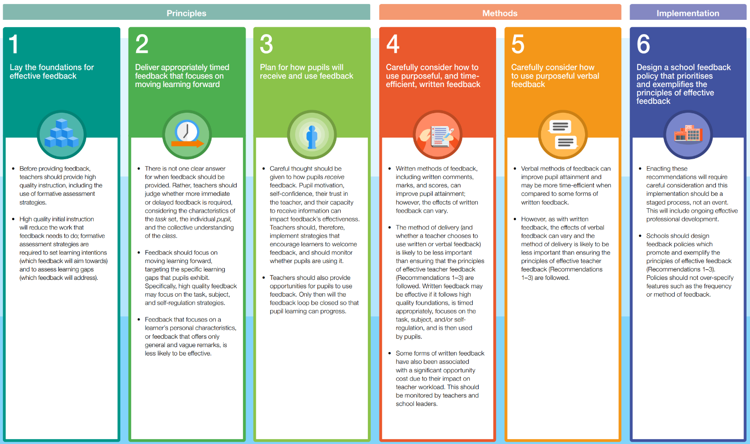

* *The Teachers' Standards* state that teachers should ‘give pupils regular feedback, both orally and through accurate marking, and encourage pupils to respond to the feedback’.
* Equally, BSO states that a school should – ‘demonstrate that a framework is in place to assess pupils’ work regularly and thoroughly and use information from that assessment to plan teaching so that pupils can progress’; (p.8 Standards for British Schools Overseas)

**Non-negotiables**:

At SQPS we will ensure that pupils get the maximum benefit from their education through an entitlement to regular advice from staff. This will enable them to understand their progress and achievement and apprise themselves of what they need to do next to improve.

We will regularly look at each other's books to uphold a high standard of presentation (see Presentation Policy), to maintain our high expectations and to inform future planning.

The quality of advice is critical and must be solely designed to allow the pupil the best opportunity to make progress.

**Principles of feedback and Feedforward at Sherborne Qatar Prep School**

* To deepen learning and allow pupils to make ‘good’ progress.
* To be rapid and immediate within lessons wherever possible.
* To employ a range of strategies that include live marking, self-assessment, peer-assessment as well as teacher assessment.
* Written feedback and advice should include a strength and target/s for further development. In addition to this, written feedback is employed as part of live marking during learning.
* Teachers regularly look at pupils’ books to help ‘feed-forward’ and plan effectively for lessons.
* Time is built into lessons develop pupil reflection through effective use of self and peer assessment.
* Not all work can be marked during the lesson, and we certainly would not want this to impact on teaching and learning in a negative way. Therefore, every child will have a combination of verbal, over the shoulder and distance marking over time.

**Quality Feedback is:**

* **Timely** (delivered soon enough after so that it can be acted upon),
* **Relevant** (to the pupil and the context – ie, Success Criteria),
* **Informative**
* **Understandable** (this relates to both the language used as well as the amount), allowing pupils to close the gap between where they are and where they need to be with their work.
* **Language rich** – meeting the needs of EAL learners. Difference in impact between verbal and something written.

**Live marking**

* Immediate marking of the work by the teacher. Pupils act immediately on this during in-class feedback.
* Teacher giving verbal feedback during lessons to small group, whole class or individuals. Pupils act upon this feedback.
* Consistent high-quality learning dialogue between teacher and pupil during the lesson. Pupils act upon this feedback.
* The teacher highlights misconceptions / incorrect work / poorly communicated subject knowledge whilst circulating in class.

**‘Pit-stop’ plenaries** will be used in lessons to stop, share and use good examples to feedforward into everyone's learning. The following model, which is based on research from the *EEF*, will be used to enable children to reflect and develop their ability to move their learning on, rather than the teacher doing it for them. We believe this is an important lifelong learning skill, linking in with our Learning Dispositions.

**Peer and Self-Assessment**

To enable reflective learning to take place, peer and self-assessment will occur on a regular basis and will usually be verbal. Teachers will model how to give constructive feedback and advice to peers. Peer and self-assessment opportunities will be evident in teachers’ planning.

**Self-assessment – (SA)**

Through a nurturing and supportive classroom environment where pupils are confident to read their work out in class and receive praise and advice in front of their peers.

* Whenever possible, the teacher provides pupils with the answers to mark their own work. This also helps their self-reflection, as it is instant feedback allowing them to consider if they understood the concept or not.
* Pupils consider their current learning against a WAGOLL (What A Good One Looks Like).
* Teachers to display Success Criteria for lessons – refer back to it at the end of the lesson giving the chn a chance to understand whether they have met, partially met or haven't met.
* Colour coded Success Criteria: Pupils mark their own work (where appropriate) when they have met/ partly met/ haven’t met (yet!) the success criteria, helping them to see what they have included/omitted in their work.

**Peer assessment – (PA)**

Possible strategies include:

* The teacher asking a pupil, in order to strengthen their understanding, to go around the classroom / work with others, marking their work. Pupils can be rotated with answers so that one is not singled out as being more able.
* Sharing good examples of pupils’ work at appropriate points in the lesson to allow pupils to reflect on their own work and share ideas for improvement.
* Photocopy examples of work, pupils peer assess on the photocopied examples, then use what they have learnt from this activity to go back and improve their own piece of work.

**Teacher marking**

* Use of written feedback and advice on selected work: This should include ‘next steps’ comment. I.e one positive comment linking back to the LO and one next steps comment.
* Where children are unable to read, this would be verbal feedback.
* Additional adults to initial a piece of work to indicate that a professional analysis / teaching & learning point has been undertaken (e.g. Teaching Assistants, cover teacher/intervention team).
* Staff indicate with an arrow in the page margin, or underline, where they want the child to review their work.
* Written comments to support future learning should be used.
* For some individual learners, e.g. children with additional needs, learning may be enhanced by other types of feedback such as stickers and stamps or a written comment.

**Summary of marking ‘codes’ (below) - to be used in conjunction with the codes on the following page …**

|  |  |
| --- | --- |
| Teacher marking | What to include |
| Professional analysis / teaching & learning point has been undertaken. | Initials on the piece of work by support staff or cover teacher |
| Child to review their work | Arrow in the page margin, or underline |

Please note:

**Errors vs Mistakes**

To provide high quality feedback for learning, a teacher needs to distinguish between errors and mistakes:

**Errors**: *a pupils will get something wrong several times in a piece of work (a skill that the pupil has not yet mastered). This needs dealing with by teaching / re-teaching that concept and not simply pointing it out… the pupils currently doesn’t have the knowledge to address it.*

**Mistakes**: *something a pupil has only got wrong once. The teacher should identify whether they ‘normally’ get this correct. In this case, teaching / re-teaching is unlikely to be necessary and therefore, high quality feedback would involve the pupil finding this mistake themselves and correcting it.*

(Source: Education Endowment Foundation)

**School Written Feedback Code**

Marking Pen Colours in Books – ALL subjects

|  |  |
| --- | --- |
| Pen Colour | Who? |
| Green | Teachers |
| Black | Teaching Assistant |
| Coloured pencil | Peers |
| Purple | Children |
| POG – pink, orange, green | LO highlighted: Pink – objective met Orange - developing Green – not met – green for growth  POG used in marking the work e.g. highlighting a fantastic sentence in pink |
| POG – pink, orange, green | Positive comment – pink then positive comment  Next steps – orange then write next steps |
| Yellow | Handwriting / letter and number formation |

Support Codes for Books

|  |  |
| --- | --- |
| Support Codes | Meaning |
| I | Independent |
| TS | Teacher supported |
| PS | Peer Supported |
| V | Verbal |
| Sp | Spelling |

For consistency, and to support whole school understanding, the above should be displayed in classes to ensure that staff and children understand and adhere to the code. The date (long date in English books and short in all other books) and learning objective (or equivalent) should be included and underlined, with a ruler (or variations depending on age group etc).

**Hot Write (assessment writing)**

Alison Philipson grids will be used for Y1-6 to assess writing. Targets will be shared with the children to ensure they are meaningful for improvement – these targets should be used throughout their English lessons. Talk-for Write toolkit (Success Criteria) will be self-assessed during hot writes.

**Homework**

It is our school expectation that all homework will be given appropriate feedback/feedforward.

**The impact of this policy is successful if:**

* teachers are able to provide clear suggestions for improvement within lessons across the curriculum
* children respond to their feedback (verbal / written / otherwise) and therefore make good progress
* time spent on feedback and advice is realistic and does not detract from other planning/practice
* feedback and advice is used to inform future planning across the curriculum