**Sherborne Qatar Prep Calculation Policy**

Progression Towards a Standard Written Method of Calculation

This calculation policy has been written in line with *White Rose Maths* and the revised National Curriculum for Mathematics (2014). It provides guidance on appropriate calculation methods and progression. The policy contains guidance from EYFS – KS2 under the four headings: **addition, subtraction, multiplication and division.**

This is a working document and something that can include new teaching methods that you all have found successful.

**Aims of the Policy:**

To ensure consistency and progression in our approach to calculation

To ensure that children develop an efficient, reliable, formal written method of calculation for all operations

To ensure that children can use these methods accurately with confidence and understanding

If at any point a pupil is struggling, they should revert to familiar pictorial and/or concrete materials/ representations as appropriate.

All lessons should show representation and consideration of any concept in Concrete, Pictorial and Abstract form. Children should be encouraged to use all three approaches when solving problems.

Children should be exposed to varied fluency using the following resources and pictorial representations including

Concrete - Base 10, Unifix, Numicon, place value charts, counters and a variety of moveable objects.

Pictorial – part whole model, bar model, place value chart, Base 10

**Addition**

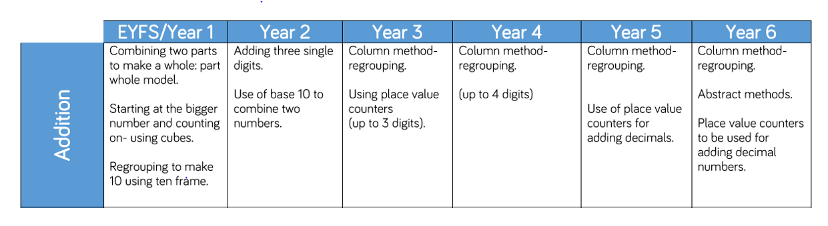

|  |  |  |  |  |  |
| --- | --- | --- | --- | --- | --- |
| STAGE | OBJECTIVE | CONCRETE | | PICTORIAL | ABSTRACT |
| **Year 1**  **Small steps**  Fact families, number bonds to 20, recognize symbols (= +), finding a part, adding together, adding more, part/whole models, number line  **Maths language**  Addition, plus, place value, hundreds, tens, ones, column, sum, total, parts, whole, add, together, more, ‘is equal to’, ‘is the same as | | | | | |
| EYFS | Counting on | Use objects to count one more | | Show pictures with one more object added | Ask what is one more than…? |
| EYFS/ Year 1 | Combining two parts to make a whole  Number bonds 5,6,7,8,9,10 | Use objects to add two numbers together as a group. Represent in variety of ways.    Split objects such as a unifix tower in different combinations. | | Use part/whole model or bar model to show two groups added together. Use numerals or objects to represent.      Show variety of ways to make the number bond.  Show the number split in variety of ways. | Draw the part whole and use the language alongside. Write the number sentence  4 + 1 = 5  4 + _ = 5  _+ 1 = 5  4 + 1 = _    Ask what is 2 more than…?  What is the sum of..? What is the total of…?  Encourage children to put the bigger number in their head and count on. |
|  |  |  | |  |  |
| EYFS/Year 1 | Counting on using number lines.  Start at the bigger number and count on. | Teach to start at larger number and count on 1 by 1 to find the answer.  Use objects alongside number line. | | Show jumps along the number line. | Show children the starting number. Ask how many more do I need? How many jumps do I need to make to get to..?  4 + _ = 9 |
| EYFS/Year 1 | Regrouping to make 10 | Use 10 frames, counters, cubes, bead strings and Numicon. | | Draw a 10 frame and fill with pictures of counters in different colours to show addition.    Draw a picture of objects and draw to show grouping of 10.    Count along the number line, showing the bridge through 10. | Show numbers and how we can find the bonds to make 10.  7 + 5 = 12  If I have 7, how many more do I need to make 10? How many more do I add on now? |
| Year 1 | Using a hundred square |  | | Children use a hundred to square to see direction of addition  48 + 36 = 84  A hundred square shows jumps down and across to denote addition |  |
| **Year 2**  **Small steps**  Fact families, number bonds to 100, recognize symbols (= + -), add and subtract 1s, 10 more and 10 less, add 2 digits, crossing 10, add three 1 digit numbers  **Maths language**  Addition, plus, place value, hundreds, tens, ones, column | | | | | |
| Year 2 | Adding 3 single digit numbers | Look for patterns, look for bonds  7 +3 + 6 = 16  7+3 = 10 then add the 6 | | Draw objects and then show how to combine to make 10. | Write the number sentence, show combining of the two numbers to make 10.    Encourage children to look for and find these short cuts. |
| Year 2/ Year 3 | Column method – no regrouping  TO + O then  TO + TO using base 10. | First build number with Base 10 then move on to place value counters  Regular focus on place value.      Build both numbers on place value grid | | Draw place value counters      Show using number line      Work alongside partitioning | Write using the T and O columns. |
| Year 3 | **Year 3**  **Small steps**  Estimate answers, Add multiples of 100, add one, two and three digits crossing 10  **Maths language**  Addition, plus, place value, hundreds, tens, ones, column | | | | |
| Year 3/4 | Column method with regrouping.    TO + TO | Build with Base 10 and show the regrouping using the ones  Use Base 10 and then place value counters | | 27 + 34 = | Carry under the column |
|  | **Year 4**  **Small steps**  Add 1s, 10s, 100s, 1000s, add two 4 digits (with exchange) estimate answers, check strategies.  **Maths language**  Addition, plus, place value, thousands, hundreds, tens, ones, column, estimate, inverse  **Year 5**  **Small steps**  Add whole numbers with more than 4 digits, round to estimate and approximate, inverse operations, multi-step addition  **Maths language**  Addition, plus, place value, thousands, hundreds, tens, ones, column, estimate, inverse. | | | | |
| Year 4/5/6 | Column method with regrouping.    HTO + HTO | Build using Base 10 and then place value counters  Show adding up ones and exchanging for 1 ten  Show starting from the ones column and moving across to tens and then hundreds | Encourage children to continue to draw pictorial representations of the columns draw place value counters | | Put the decimal place in and layout as shown. |
|  | **Year 6**  **Small steps**  Add whole numbers with more than 4 digits, round to estimate and approximate, inverse operations, multi-step addition, mental calculations and estimation  **Maths language**  Addition, plus, place value, thousands, hundreds, tens, ones, column, estimate, inverse. | | | | |
| Year 5/6 | Add with several numbers of increasing complexity | As children move to decimals, money and decimal place value counters can be used to support learning. | |  | Add ‘zeros’ to show place value of decimals |

**Subtraction**

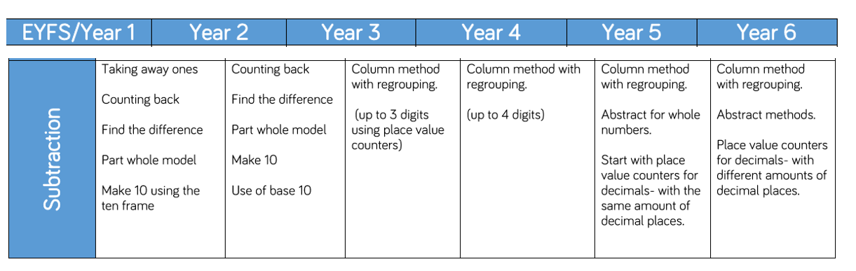

|  |  |  |  |  |
| --- | --- | --- | --- | --- |
| STAGE | OBJECTIVE | CONCRETE | PICTORIAL | ABSTRACT |
|  | **Year 1**  **Small steps**  Fact families – the 8 facts, number bonds to 20, recognize symbols (= -), finding a part,part/whole models, numberline, subtraction crossing out, breaking apart, counting back  **Maths language**  Take away, less than, the difference, subtract, minus, fewer, decrease. | | | |
| EYFS/Year 1/ Year 2 | Taking away ones | Use variety of objects to show physically taking away and removing objects from the whole number.  Recount and check remaining number. | Model drawings and encourage children to draw the concrete resources they are using and cross out the correct amount.  Showing objects in a row builds to bar model. | How many less? Count back.  Show number sentences. |
|  | **Year 2**  **Small steps**  Subtraction facts to 20, check calculations, compare number sentences, related facts, subtract 1s and 10s, bonds to 100 (tens, tens and ones), subtract 2 digits from 2 digits, crossing 10,  **Maths language**  Fact families – the 8 facts, number bonds to 100, recognize symbols (= -), finding a part,part/whole models, numberline, subtraction crossing out, breaking apart, counting back | | | |
| EYFS/Year 1/ Year 2 | Counting back | Count back removing objects from a group  Count back in ones on number line or bead strings | Start at the bigger number and count back, showing jumps.  First count in steps of 1 and then build up. | Show putting a number in your head and then counting back. |
| EYFS/Year 1/ Year 2 | Finding the difference | Use position of objects to show and calculate the difference. | Draw cubes or objects and then illustrate with a bar model. | Use number stories and word problems.  Say find the difference between… |
| Year 1/ Year 2 | Part/whole model | Use the part whole model to show inverse operations. Start to introduce missing numbers. | Use part whole model with pictorial objects. | Put the numbers in the part whole model |
| Year 1/Year 2 | Making 10 | Use 10 frame to show | Children draw 10 frames and show how reach 10. | Encourage children to count back through 10s. |
| Year 1 | Using a hundred square | By using a hundred square this reinforces direction of going backwards for subtraction and jumping forward for addition.  74 – 27  Jumps are made up and back to denote subtraction |  |  |
|  | **Year 3**  **Small steps**  Subtract multiples of 100, subtract 3 digits from 3 digits crossing 10 and 100, spot the pattern, estimate, check calculations.  **Maths language**  Fact families – the 8 facts, number bonds to 100, recognize symbols (= -), finding a part/whole models, number line, subtraction crossing out, breaking apart, counting back, column, hundreds, tens, ones, inverse, estimation, calculation | | | |
| Year 2/Year 3 | Column method without regrouping (using Base 10) | Make the bigger number using Base 10 and show taking away the smaller number | Draw Base 10 or place value counters alongside the written calculation | Children write column subtraction in T and O column |
|  | **Year 4**  **Small steps**  Add and subtract 1s, 10s, 100s, 1000s, subtract two 4-digit numbers more than one exchange, efficient subtraction, estimate answers, check strategies  **Maths language**  Fact families – the 8 facts, number bonds to 100, recognize symbols (= -), finding a part,part/whole models, numberline, subtraction crossing out, breaking apart, counting back, column, hundreds, tens, ones, inverse, estimation, calculation  **Year 5**  **Small steps**  Subtract whole numbers with more than 4 digits (column method), round to estimate and approximate, inverse operations, multi- step problems  **Maths language**  Exchange, column, ten thousands, thousands, hundreds, tens, ones, inverse, estimation, calculation | | | |
| Year 3/Year 4/Year 5 | Column method with regrouping (using Base 10) | Build the number using Base 10 and show exchange. Show again using place value counters.  Make the bigger number, show starting with ones – can I take away 6 from 4? No, so I need to exchange one of my tens for ones.  224 – 26 = | Represent Base 10 pictorially remembering to show the exchange.  Draw counters onto place value grid. Cross out counters to show exchange. | Children show exchange as shown.  Talk through why the number is crossed out. Why have we exchanged a ten? Discuss place value of the tens so we understand process. |
|  | **Year 6**  **Small steps**  Subtract whole numbers, mental calculations and estimation, reason from known facts  **Maths language**  Exchange, column, ten thousands, thousands, hundreds, tens, ones, inverse, estimation, calculation | | | |
| Year 5/ Year 6 | Subtract with increasingly large and more complex numbers and decimal values. |  | Continue to explicitly talk about exchanging. The number is the same however we have exchanged so that we can subtract the ones/ tens/hundreds. | |

**Multiplication**

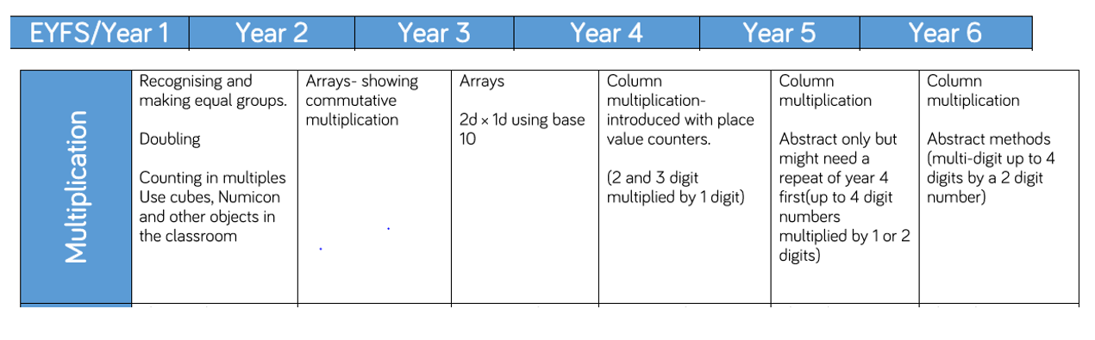

|  |  |  |  |  |
| --- | --- | --- | --- | --- |
| STAGE | OBJECTIVE | CONCRETE | PICTORIAL | ABSTRACT |
|  | **Year 1**  **Small steps**  Count in 2s, 5s, 10s, make equal groups, add equal groups, make arrays, make doubles  **Maths Language**  Equal, array, repeated addition, groups | | | |
| EYFS/ Year 1 | Doubling | Use objects to show doubling | Draw pictures to show how to double a number. | Partition, double, add back together. |
| EYFS/Year 1 | Counting in multiples | Count in multiples supported by concrete objects in equal parts. Show using wide variation. | Use number lines with objects above. | Write number sequences.  Count in multiples aloud.  2 x 2 =  4 x 2 =  6 x 2 =  3 x 4 =  2,4,6,8,10.12,14,16,18,20  3,6,9,12,15,18,21,24,27,30,33, |
| Year 1 | Repeated Addition | Repeat groups of objects and show repeated addition alongside multiplication. | Show repeated groups. Use familiar associations (2s pair of socks, 5s fingers on a hand) | Write repeated addition alongside objects and pictures. |
|  | **Year 2**  **Small steps**  Recognise equal groups, make equal groups, add equal groups, multiplication sentences using the x symbol, multiplication sentences from pictures, arrays, 2, 5 and 10 times-table.  **Maths language**  Equal, array, repeated addition, groups, multiply | | | |
| Year 1/ Year 2 | Number lines showing repeated groups | Show the repeated addition with objects alongside | Draw objects within number lines | Write number lines and numerals |
| Year 2 | Arrays showing commutative multiplication | Create concrete arrays using a variety of objects | Draw arrays as circles similar to the counters | Write numbers sentences to match array  Multiplication and repeated addition.  3 x 4 = 12  4 x 3 = 12  12 4 = 3  12 3 = 4 |
|  | **Year 3**  **Small steps**  Multiplication equal groups, multiply by 3, 4, and 8, comparing statements, related calculations, multiply 2 digits by 1 digit, scaling.  **Maths language**  Equal, array, repeated addition, groups, multiply, times table, bar model, scaling | | | |
| Year 2/ Year 3 | Grid method | Use arrays to introduce grid method – in full . Use counters.    Next use place value counters.  If multiplying by 4, show you need 4 rows. | Draw in same way as created with concrete resources. | Write numbers in grid and then write number sentences alongside. |
|  | **Year 4**  **Small steps**  Multiply by 1 and 0, multiply by 10 and 100, multiply by 6, 9 and 7, 11 and 12, multiply three numbers, efficient multiplication, multiply 2 digits by 1 digit, multiply 3 digits by 1 digit,  **Maths language**  Equal, array, repeated addition, groups, multiply, times table, bar model | | | |
| Year 3/ Year 4 | Partition to multiply | Numicon works well or Base 10.  4 x 15 = | Draw concrete resources pictorially. | Partition and show number sentences.  Encourage children to show and check each step. |
|  | **Year 5**  **Small steps**  Multiples, factors, multiply by 10, 100, 1,000, multiples of 10, 100 and 1,000  Multiply 4-digits by 1 digit, multiply 2 digits, multiply 3 digits by 2 digits multiply 3 digit by 2 digits, multiply 4 digits by 2 digits. | | | |
| Year 4/ Year 5 | Column multiplication | Support with place value counters. Keep reinforcing starting from the ones.  3 x 23 | Draw counters pictorially | Write out in columns.  Show what is being solved next to the answer.  3 x 23  3 x 20 = 60  3 x 3 = 9  60 + 9 = 69  23  x 3  69 |
|  | **Year 6**  **Small steps**  Multiply up to a 4-digit number by 1-digit, mental calculations and estimation, reason from known facts. | | | |
| Year 6 | Column Multiplication  Multiply decimals | 6 x 23 |  | Written in grid.        4.9 x 3 |

**Division**

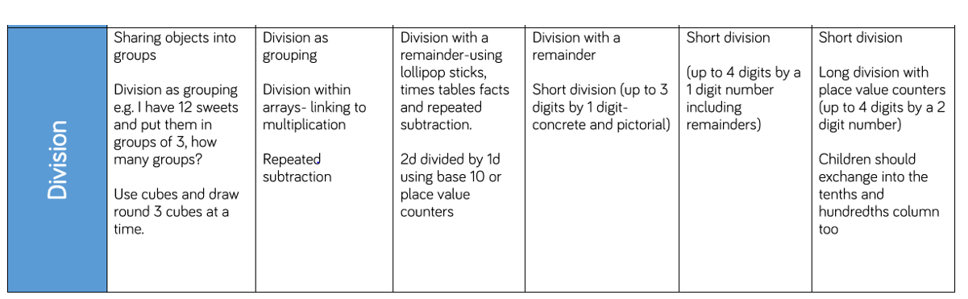

|  |  |  |  |  |
| --- | --- | --- | --- | --- |
| STAGE | OBJECTIVE | CONCRETE | PICTORIAL | ABSTRACT |
|  | **Year 1**  **Small steps**  Count in 10s, make equal groups, add equal groups, make arrays, make doubles, make equal groups (grouping), make equal groups (sharing)  **Maths Language**  Equal, array, groups, divide, division | | | |
| EYFS/ Year 1 | Sharing objects into groups | Support children to share equally into two groups. One for you, one for you. Check and count equal groups. | Draw groups | Write number sentences alongside.  Read and write number stories about division.  Share 9 apples between 3 people.  If there were 6 pens to share between 2 children, how many would each child get? |
| EYFS/Year 1/ Year 2 | Division as grouping/ Repeating subtraction | Show division as repeated subtraction along number line. Use objects to show division into groups. Check each group is equal. Demonstrate sharing between groups. | Show the bar as a whole. Split it into the number of groups you are dividing by and then work out how many are in each group. | Write numerals on number lines. |
|  | **Year 2**  **Small steps**  Recognise equal groups, make equal groups (sharing), make equal groups (grouping), divide by 2, odd and even numbers, divide by 5, divide by 10  **Maths language**  Equal, array, groups, divide, division | | | |
| Year 2 | Division with arrays | Create arrays as with multiplication and think about the inverse. Show all the number sentences that can be created from one array. | Draw an array and use lines to split it into groups. Write the 4 number sentences alongside. | Write the four associated number sentences for each array.  7 x 3 = 21  3 x 7 = 21  21  3 = 7  21  7 = 3 |
|  | **Year 3**  **Small steps**  Divide by 3, divide by 4, divide by 8, 3,4,8 times table, comparing statements, related calculations, divide 2 digits by 1 digit, how many ways?  **Maths language**  Equal, array, subtraction, groups, divide, times table, bar model, scaling | | | |
| Year 3 | Division with remainder | Count out objects such as matchsticks/lolly sticks and divide into triangles (division by 3), squares (division by 4) How many left?  Divide objects into groups. Are there any left over? Show remainders. | Children draw the triangles and squares.  Children draw the groups. | Write number sentence for the pictorial representation. |
|  | **Year 4**  **Small steps**  Divide by 1, divide by 10, divide by 100, multiply and divide by 6, 6 times table and division facts, multiply and divide by 9, 9 times table and division facts, multiply and divide by 7, 7 times table and division facts, written methods, divide 2 digits by 1 digit, divide 3 digits by 1 digit, correspondence problems.  **Maths language**  Equal, array, repeated subtraction, groups, divided, times table, bar model | | | |
| Year 4/ Year 5 | Short division | Use place value counters to divide a 3 digit number by 1 digit. Show partitioning.  Move to 4 digit number.  615 divided by 5 | Children should continue to group objects pictorially.  Children can represent place value counters. | Division no reminder    Division with remainder    Decimal places to divide total correctly. |
|  | **Year 5**  **Small steps**  Factors, common factors, prime numbers, square numbers, cube numbers, divide by 10, 100 and 1,000  **Maths Language**  Divide, inverse, place value  **Year 6**  **Small steps**  Short division, division using factors, long division, common factors, common multiples, primes, squares and cubes, order of operations, mental calculations and estimation, reason from known facts | | | |
| Year 5/ Year 6 | Long division |  | | |