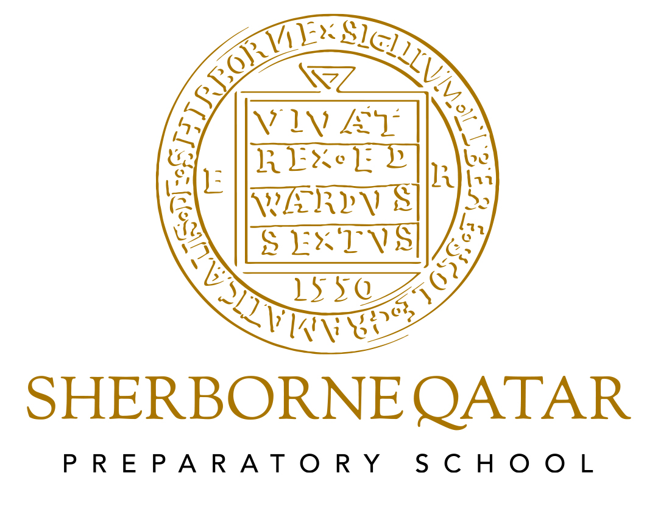

Early Years Foundation Stage Policy

Early Years Foundation Stage Policy

Last Updated June 2024
Next review June 2025
Reviewed by Eva Taggart (Head of Pre- Prep)
Early Years Foundation Stage Policy

“When we succeed in giving every child the best start in their early years, we give them what they need today. We also set them up with every chance of success tomorrow.” Development Matters Sept 2020

Within this document, the term Early Years Foundation Stage is used to describe children who are in our Pre School and Reception classes.

- We provide opportunities and environments that stimulate curiosity;
- We observe and listen closely and take the child’s lead;
- We pick up on things that have sparked the child’s interests;
- We use open ended questions;
- We praise and reinforce positive learning experiences.

Aim

At Sherborne Qatar Preparatory School (SQPS) we aim to provide the highest quality care and education for all our children thereby giving them a strong foundation for their future learning. We create a safe and happy environment with motivating and enjoyable learning experiences that enable children to become confident and independent. We value the individual child and work alongside parents and others to meet their needs and help every child to reach their full potential.

As outlined in the Early Years foundation stage statutory framework, all children deserve the care and support they need to have the best start in life. Children learn and develop at a faster rate from birth to five years old than at any other time in their lives, so their experiences in early years have a major impact on their future life chances.

We adhere to the Revised Statutory Framework of the EYFS and the four guiding principles that shape practice within Early Years settings:

- Every child is a unique child, who is constantly learning and can be resilient, capable, confident and self-assured;
- Children learn to be strong and independent through positive relationships;
- Children learn and develop well in enabling environments, with teaching and support from adults, who respond to their individual interests and needs and help them to build their learning over time. Children benefit from a strong partnership between practitioners and parents and/or carers.
- Children develop and learn in different ways and at different rates;

Foundation Stage Curriculum
Our curriculum comes from the children; the things they are interested in; the things they are good at; the things we know they need to make good progress and the things we hope they will really enjoy.

Curriculum Principles:
- Start from the children, ask them what they enjoy and what they want to learn next, talk to their parents, observe them playing and learning;
- Practical, first-hand experiences, initiated by children’s interests, lend themselves to the richest learning opportunities;
- Enabling environments with quality resources and sensitive adult support responsive to children’s needs help children to become independent learners;
- Learning through play is most meaningful to young children and leads to deeper learning;
- Curriculum provision reflects the rich and varied cultures in our local community and beyond.

We plan an exciting and challenging curriculum based on our observation of children’s needs, interests, and stages of development across the seven areas of learning to enable the children to achieve and exceed the early learning goals.

Planning and guided children’s activities will reflect on the different ways that children learn and reflect these in their practice. At SQPS we support children in using the three characteristics of effective teaching and learning. These are:
- playing and exploring - children investigate and experience things, and ‘have a go’;
- active learning - children concentrate and keep on trying if they encounter difficulties, and enjoy achievements; and
- creating and thinking critically - children have and develop their own ideas, make links between ideas, and develop strategies for doing things. (Taken from statutory framework for the EYFS 2024).

All the seven areas of learning and development are important and inter-connected.
Three areas are particularly crucial for igniting children's curiosity and enthusiasm for learning, and for building their capacity to learn, form relationships and thrive.
These three areas are the prime areas:
- Communication and Language;
- Physical Development;
- Personal, Social and Emotional Development.

Children are also supported through the four specific areas, through which the three prime areas are strengthened and applied.

The specific areas are:
- Literacy;
- Mathematics;
- Understanding the World;
- Expressive Arts and Design;

Children are provided with a range of rich, meaningful first-hand experiences in which children explore, think creatively and are active. We aim to develop and foster positive attitudes towards learning, confidence, communication and physical development.
Children have whole group and small group times which increase as they progress through the EYFS with times for a daily phonics session using Read, Write Inc., teaching aspects of Mathematics and Literacy, including shared reading and writing.
The curriculum is child-centred and is based around principles contained in the Early Years Foundation Stage. Environments and resources are developed in response to children’s interests and next-step learning needs across all areas of their learning. Sometimes a number of children become interested in the same thing and topics emerge. The teacher will sometimes introduce new resources and experiences to stimulate new interests in the children.

Planning
At Sherborne Qatar Preparatory school, teachers provide provocations to ignite curiosity, use ‘In the Moment Planning and also lead activities to plug gaps in learning. Phonics, Mathematics, PE and Music are planned and taught daily or weekly by the form teacher or specialist teachers. Time is used at carpet time through the day to give the children an opportunity to talk about what they have learnt and in most cases the teacher can use this as a whole class teaching opportunity or to consolidate knowledge.
We aim to:
- Start from the child, recognising that each child is unique;
- Focus on their needs, development and interests;
- Provide an enabling environment that allows for spontaneity and creativity;
- Provide children with experiences and opportunities so that they can learn, practise and develop their skills and knowledge;
- Provide interesting, varied and stimulating learning opportunities that covers all areas of the curriculum;
- Observe and listen to the child;
- Involve and listen to parents/carers;
- Involve all practitioners working in the setting as well as the expertise from other professionals involved in the individual child’s education, health and care.

In our planning, the learning opportunities are weighted towards child-initiated activities but also include adult led learning and adult supported activities.

Child Initiated Activities

Child initiated activities are those that children choose and pursue independently, either individually or in a group. These can be developed by us through resources planning but the nature of what happens is decided by the children. Child initiated learning can be supported by adding extra resources, extending play, challenging children’s thinking through carefully framed questions and teaching a specific skill for them to use during their child-initiated learning.

Adult Led Learning

Adult led learning are those activities that are planned for and directed by an adult. They include whole group or small group activities. Sometimes these include activities devised by an adult that children are directed to undertake independently.

Adult Supported Activities

Adult supported activities are activities chosen independently by the children but where an adult observes that their support will help scaffold the child’s learning and move them on. This intervention takes the form of extending the child’s language through talk. For example, asking open ended questions.

Enabling Environments
The environment supports children to be fully engaged in purposeful play of their own choice and interest. As with the outdoor area, the indoor area allows for learning in all areas of development, but the two areas do not mirror each other. This is the ideal place for children to be calm and quiet (and we enforce this requirement firmly and consistently), pursuing activities which require small equipment and using resources that will not survive the outdoor elements. In the EYFS classes, the children choose where to go and what to do from the moment they arrive – they initiate their own learning and adults join them and support them in their pursuits. In all areas, the resources are available and accessible to the children at all times, but nothing is set out. The areas are clear, stocked and tidy at the start of the day: the children can choose whether or not to go to an area and what to do if they do go there.

We aim to create an attractive and stimulating learning environment where children feel confident, secure and challenged. The children have daily access to an indoor and outdoor environment that is set up in discrete areas of learning with planned continuous provision.

Role of the Adult
The most valuable resource in any setting is the group of adults. The adults are there to teach, they do this though observing and interacting. We ensure that our adults receive training so that they can spot a ‘teachable moment’ while the children are engaged, they know the children very well and have a sound understanding of child development. This ensures that the adults enhance and extend the learning at the appropriate level for each unique child. Generally, the adults go to the children. The children become involved in activities of their choice. The adults observe the children carefully, join them, when appropriate, and engage in quality interactions (teaching) to move the learning on, they ‘teach’ through modelling, suggesting, providing vocabulary or resources, explaining or encouraging. In this way, if a child encounters a challenge, then they will not give up. Rather they will be supported to persevere, overcome the challenge and move forward in their learning.

Assessment and Observation
Assessment mostly happens in the moment. Teachers and practitioners are constantly looking and asking questions to find out what children know and understand so they can adapt their teaching and the activities they provide to support next step learning for each child. They use the information they have found out to make changes straight away or to plan things for the next lesson.

The Early Years Framework asserts that ‘assessment should not entail prolonged breaks from interaction with children, nor require excessive paperwork…practitioners should draw on their knowledge of the child and their own expert professional judgement and should not be required to prove this through collection of physical evidence.’

All observations made of the children must be based on quality interactions between children or children and practitioners. They must include any teaching that has taken place or progress that a child or group of children have made. All practitioners are responsible for highlighting progress in observations. Emphasis is highly placed on using ‘I wonder…’ statements i.e. ‘I wonder if…’, ‘I wonder what…’, ‘I wonder how…’. We feel that this approach to questioning is a lot less pressurising and allows the children to open up more readily.

We record our observations in a variety of ways. Everyone is encouraged to contribute and discussions take place. Significant observations of children’s achievements are collated in their own personal learning journey, using iTrack. These on-going observations are used to inform the planning and pupil progress meetings.

The Head of Pre – Prep meets with the Form Teacher and then the Head of Year, SENDCO and Deputy Head each half term in order to discuss progress of individuals and groups of children. Wherever children are not making good progress, we plan additional support for individuals or groups of children. We make sure parents and carers are informed if their children are receiving additional support.

Parent meetings are held twice a year and, at these meetings, parents are invited to discuss their child’s pastoral and academic needs.

In Pre-School and Reception, teachers make assessment judgments on a child’s all-round progress at the end of each term. At the end of Term 3, parents receive a full report for each area of the EYFS as well as comments from the specialist teachers. Targets are provided to support parents with their child’s next steps. The child’s achievements are reported to parents against the Early Learning Goals in the Early Years Foundation Stage Profile.

Safety
Children’s safety and welfare is paramount. We create a safe and secure environment and provide a curriculum which teaches children how to be safe, make choices and assess risks.
We promote the good health of the children in our care in numerous ways, including the promotion of nutritious food and by following set procedures when children become ill or have an accident.
Please see our separate policies and procedures on Health and Safety, Child Protection and Medical policy.

Intimate Care
No intimate care is to be given without the express written permission of the parent or guardian of that child and all parents and guardians will be asked to provide that permission when their child joins. The Head of Year reserves the right to phone parents and ask them to come in a clean their child or take home if they have had more than two cases during the day. Pre-school and Reception children should all be fully toilet trained before starting school and the Head of Pre-Prep reserves the right to dismiss a child until toilet trained. For details of the school’s Intimate Care Policy please refer to the Child Protection Policy.

Inclusion
We value all our children as individuals at Sherborne Qatar Preparatory School, irrespective of their ethnicity, culture, religion, home language, background, ability or gender. We plan a curriculum that meet the needs of the individual child and support them at their own pace so that most of our children achieve and even exceed the Early Learning Goals. We strongly believe that early identification of children with additional needs is crucial in enabling us to give the child the support that they need and in doing so, work closely with parents and the Intervention Team.
Equal Opportunities
All members of the school are treated as individuals. We aim to meet the needs of all, taking account of gender, ability, ethnicity, culture, religion, language, sexual orientation, age, special educational needs, disability, and social circumstances. All staff are aware of the need for the curriculum to reflect cultural diversity and the need to prepare pupils for life in a diverse and multi-faith society.

Transitions
Transitions are carefully planned for and time given to ensure continuity of learning. At any transition, we acknowledge the child’s needs and establish effective partnerships with those involved with the child.
In the final term of Pre-school and Reception, the respective teachers in Reception and Year 1, liaise to discuss the individual children, their needs and analyse the assessment data to inform planning. Pastoral and academic meetings take place to ensure a smooth transition from one year to the next.
Parents as Partners
We fully recognise the importance of the essential link between school and home to fully maximise each child’s potential.

The ways in which we foster this relationship include:
- Parent information sessions before children start at Pre-School;
- Regular workshops to provide education and support to parents both pastoral and academic;
- Regular communication via Class Dojo such as photos and videos and upcoming events and notices – translated through the app;
- iTrack– an online platform on which photos and assessments are collated;
- Stay and Play sessions for parents to come and join the learning in school;
- An ‘Open Door’ policy so that parents can meet the teachers and maintain regular communication;
- Parents Reps – there to be the ‘voice’ of the parent community and provide a strong link between school and home;
- Parent handbooks containing information to support families with the transition to EYFS.

EYFS and the 2030 vision
We know that our youngest learners will be key players in the Qatar of the future. It is paramount that they understand from an early age the values and learn the culture of this fast changing and developing country. We weave in our own school values and learning dispositions across the EYFS curriculum and, in doing so, deepen the children’s understanding of how these reflect Qatar as a wider community.
Working together and celebrating the diversity that our multi- cultural cohorts offer us, we incorporate a foundational understanding of the four pillars.
At SQPS, we are educating the next generation, we are responsible for the success of each of those four pillars as education is at the core of each. It is a privilege to be able to help form the future leaders and be part of the exciting journey that Qatar is on as we approach 2030.

