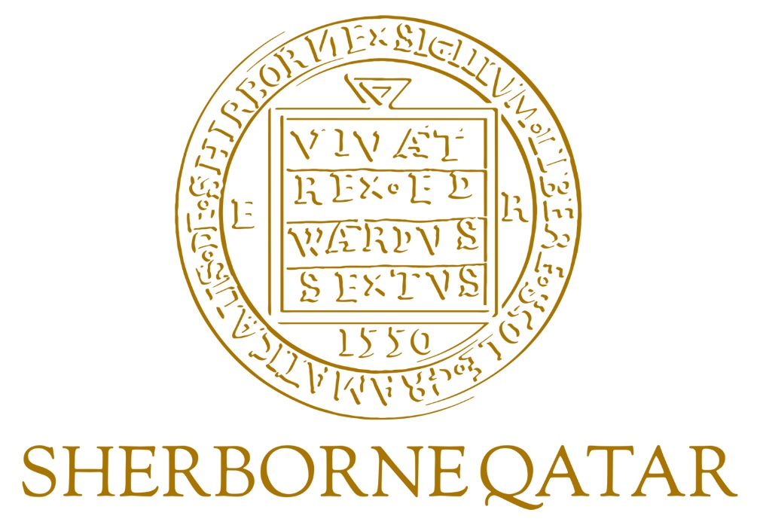

**Culture Awareness**

**at**

**Sherborne Qatar**

**Reviewed 16/6/24 by Heidi Berry, Headteacher**

**Cultural Awareness at Sherborne Qatar**

**Recruitment**

In January any staff vacancies for the following academic year are advertised via the Schools’ website and online within the Times Education Supplement – TES. Candidates are provided with a Candidate Brief for each school which outlines, right from the very outset, what is expected from a member of staff at Sherborne Qatar. Additionally, it details the dress code policy and includes the statement;

*All members of staff serve as role models for Sherborne Qatar pupils and the wider*  
*community. All colleagues should therefore dress professionally and appropriately,*  
*showing respect for local traditions and expectations.*

In February the Principal and the Heads host recruitment interviews in London, in Qatar and online. During the interviews they present a short video on life in Qatar and reinforce the changes they would need to embrace moving to Qatar.

**INSET / Induction Week**

New staff meet together online with the Head or in person at the July inset. This is an important time when excitement starts to build, colleagues start to bond and any concerns and fears are addressed before taking off.

A week prior to the start of the new academic year all staff congregate in their respective schools for the autumn INSET programme. The Heads of Arabic in the Prep, Senior and Girls’ Schools hold sessions on cultural awareness which all staff attend. These act as an introduction to life in Qatar for new staff and a reminder to existing staff. Additionally, staff are given the document Guidelines on Islam and Arab Culture. The document lists the areas where staff should exercise caution in relation to political & religious issues and traditions and conventions.

**Director of Arabic & Islamic Studies**

Staff are encouraged to liaise with The Director of Arabic and Islamic Studies on any cultural queries they may have. These may relate to the appropriateness of any teaching material or an enrichment / extracurricular event they wish to run in school. The Director also acts as the Ministry of Education’s Compliance Officer. Staff are advised that although we try our utmost it is inevitable that occasional cultural mistakes will be made. If a member of staff thinks they have made an error of judgment they should immediately alert the Head and the Director of Arabic and Islamic Studies.

**Handbooks**

In addition to the Schools’ Handbooks we also have a Parents’ Welcome Pack that affirms that:

*‘We make every effort to cater for and respect the dietary, prayer and cultural needs of*  
*each religion and ethnic group. If your child has particular needs please do not hesitate to speak to a member of staff.’*

The Staff Handbooks for the schools naturally include information on the Dress Code (as detailed above) but they also include the following statement regarding expectation;

*Colleagues are expected to conduct themselves in a professional manner at all times and remember that we are guests in Qatar, and so we should respect our hosts’ culture. Members of the public can, and may, report any behaviour which is inappropriate in the local context.*

Staff behaviour on social media is also an area that is highlighted and it is stressed that staff must act appropriately at all times. The Handbooks detail;

*Staff are also advised to think very carefully about what they post on social media and to think very carefully about the cultural expectations of the country in which we live and work. If you are in any doubt about the appropriateness of an item or photograph, don’t post it and seek advice.*

**Personal, Social and Health Education (PSHE)**

All the schools take a full and thorough approach to PSHE. The purpose is to encourage our pupils to make a positive contribution to the life of the schools and the wider community. In doing so, we develop their sense of self-worth. We ensure that they experience the process of democracy in school through, for example, the Schools’ Councils. We teach them about rights and responsibilities. They learn to appreciate what it means to be a positive member of a diverse and very multi-cultural community. The PSHE programme is delivered via lessons, school assemblies and early morning tutor time. The pupils will take part in sessions on the Schools’ Values – Responsibility, Honesty, Perseverance, Kindness, Teamwork and Respect. They will cover topics such as tolerance, cyber bullying and personal appearance; all the while respecting Qatari culture and ensuring adherence to local rules.

**Prep School Computer and Internet Policy**

The Prep School’s policy for responsible internet use by pupils is sent out electronically to all pupils and parents who are required to sign it. Form Teachers are responsible for ensuring all the document is returned for each pupil and Heads of Key Stage make periodic checks. Parents are also given the option to allow or disallow the use of their children’s photographs in official school publications and on the website.

For day to day use within the classroom staff are required to download and preview videos before showing them to the pupils and there should be no random searching of videos in front of pupils. There are two key reasons for this:

1. So that staff can be sure that they are not inadvertently going to show to the pupils material which is culturally inappropriate;
2. Depending on the quality of the original, downloading ‘live’ uses up to 50% of the available bandwidth and so has a major knock on effect for all other internet usage across the school.

If staff are at all unsure about the content of a video, they are asked to refer to the Director of Arabic and Islamic Studies for guidance.

In addition, there are fire walls in place to prevent access to certain sites.

**Ramadan Hours**

In consultation with the Schools’ governing body and the Ministry of Education the schools adapt the teaching and working day for all staff to ensure the Holy month of Ramadan is respected. The school day is typically reduced to 4 hours of teaching and staff are required to work 5 hours each day. Staff who are fasting are also permitted to teach fewer lessons. All staff and pupils must refrain from eating and drinking in public. Provision is made for pupils and staff who are not fasting to take their breaks discreetly. Additional measures are put in place to manage examinations. For example, pupils who are fasting would be sat at the front of the examination room to allow for other pupils to take in water should they need to.

**Home School Agreement**

The schools ask for families to sign up to their respective Home School Agreements. The schools make every effort to give all pupils the opportunity to realise their full potential and we believe that a partnership between home and school is essential if we are to realise that aim. The schools, for example, commit to Parents that they will:

* *provide a secure, happy and stimulating learning environment in which we encourage all pupils to do their best in all situations;*
* *provide a broad and balanced curriculum which challenges all pupils to fulfil their potential.*

The Parents are asked to commit, for example, to:

* *accept the school’s aims and values, and positively support the school.*

The Pupils are asked to commit, for example, to:

* *…always try my best in everything I do in school;*
* *take pride in my school and wear my uniform with pride;*
* *acknowledge our school values – honesty, respect, perseverance, teamwork responsibility; kindness – and reflect them in everything we do.*

**Pupil Dress Code**

When pupils enrol at Sherborne Qatar parents are provided with a pack of information that includes details on dress code. The details are also located on our website at [www.sherborneqatar.org](http://www.sherborneqatar.org). Within our policy we stipulate, for example, that girls may wear a hijab instead of a neck tie and that skirts must be at least to the knee. Adherence to our dress code is policed on a daily basis by senior management teams and form tutors across both schools.

**The Schools’ Environment**

Both schools have boys and girls prayer rooms available throughout the day for staff and pupils alike to use. Washing facilities are located nearby.

We ensure photographs of the Emir and Father Emir are displayed in the reception areas of both schools. The Qatari flag is proudly displayed at the schools, as is the Union Jack of the United Kingdom.

**School Activities**

Qatar National Day is a huge date in the schools’ diaries. Lead by the Arabic Department pupils are encouraged to come into school wearing national dress. A whole host of interesting displays are put on in celebration of Qatar’s rich culture and heritage.

As part of the trips arranged throughout the year, pupils have the opportunity to visit the National Museum of Qatar to gain a better understanding of the country they are living in.

**Ministry and Fellow Schools Liaison**

We are proud of the relationship we have formed with key figures at the Ministry of Education and are always happy to support and promote initiatives and help in any manner we can. This includes, for example:

* leading and supporting the Beacon Schools Project;
* promptly providing health monitoring data to the Ministry of Health;
* welcoming groups of fellow schools (at the request of the MoE) to share good practice and them to understand why Sherborne pupils like being here, and Sherborne staff like working here;
* taking part in the review of the teaching of Arabic and Islamic Studies;
* attending the child protection policy review.