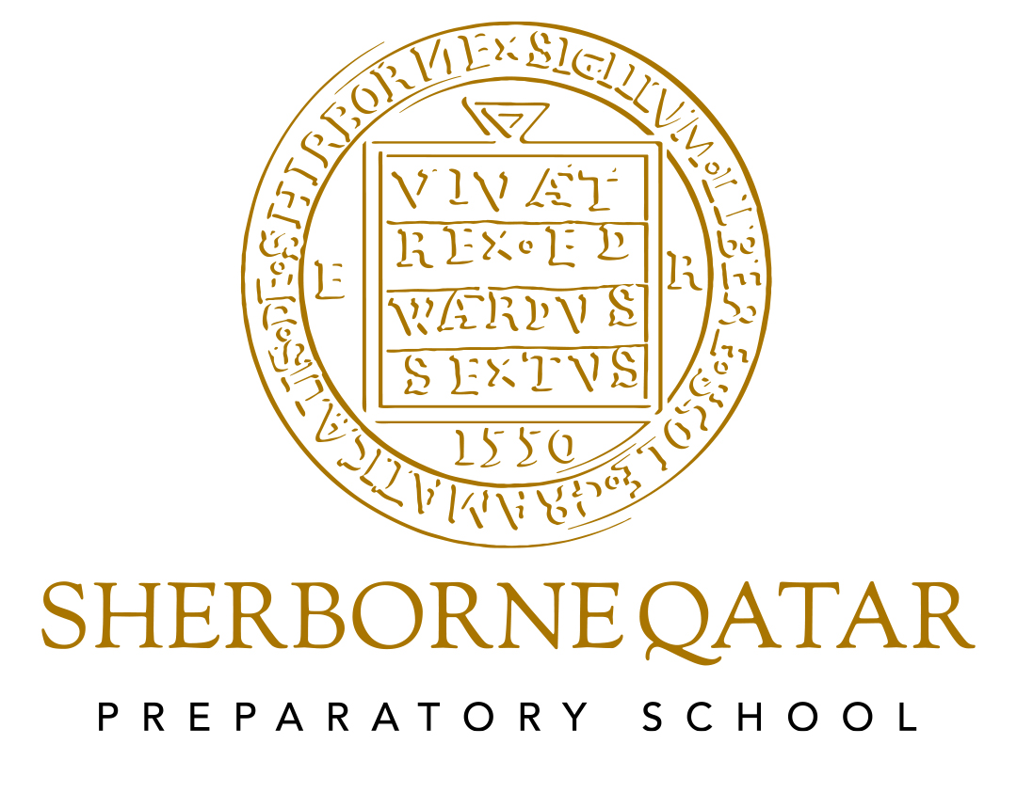

Presentation and Display Policies

Presentation and Display Policies

Reviewed – June 24
Next review – June 25
Reviewed by Heidi Berry, Headteacher

Contents
Presentation | Page 3
Display | Page 4

Presentation
Aims
The purpose of this policy is to produce a consistent approach towards the presentation of work throughout the school. Children should all be aware of the standards expected of them and know that this will apply whichever teacher is taking the class. It will ensure expectations are raised by all staff and engender in all children a sense of pride in how their work should look.
Organisation
Both sides of the paper should be written on, and each page filled before turning to the next. Work can be ruled underneath and a new date to signify the next piece of work.
- Each piece of work must be dated. As a model for this the teacher must write the date on the board. The short version of the date, with "dots", i.e. 24.03.20 is to be used in Maths and Science books and on worksheets, but the long version i.e. Thursday 24th March 2025 should be used in English books. The teacher’s judgement as to when to use the long/short date should be used for anything else. Children should learn how to spell the days of the week and months of the year. The date should be underlined using a ruler and pencil
- Each piece of work should also have a learning objective. This should be under the date and underlined using a ruler. EYFS and KS1 use WALT (We Are Learning To) and Year 3 up use LO (Learning Objective)
- Children’s dates and WALTs can be typed and printed in EYFS and KS1
- Children will write on every line. The only exception to this may be during a creative/extended writing activity where teachers may need the space to correct any errors clearly or where the child may need the space to re-draft and/or include new ideas
- Tippex/correction fluid is not allowed
- Pencils should be used for all drawing activities and maths lessons
- Pens may only be used in writing by those children with a pen licence.
- A child should not write or draw anything on the covers of any exercise books (other than their name and Form name)
- A child should not "doodle" or in any other way mark any of the pages in their exercise books
- Felt Tip pens and gel pens should not be used in any exercise books. Drawings or diagrams must be done in pencil and straight lines drawn with a ruler unless it is intended to be a rough sketch.
Curriculum
For examples of laying out specific books please see the relevant subject’s handbook.
Learning Journeys
WALT (EYFS) or LO should be written on every new piece of work.
Work should be on paper that is then stuck into the books.
Any photographs that are stuck in should be labelled.
Felt tips may be used.

Displays

Introduction

Display is highly valued at Sherborne Qatar Prep School (SQPS) as a way to show that children’s efforts are valued and to create a lively, informative and stimulating environment in which we all work and learn. Display should be an integral part of the on-going school programme and an important part of the teacher’s planning.

We aim to produce displays that reflect a broad and balanced curriculum both in the classrooms and in the shared areas
- To celebrate the achievement of all children
- To support teaching and learning
- To provide a visually stimulating environment
- To convey standards, values and high expectations
- To share with the wider community what is being done in each class
- To encourage the children to care about and be involved in their environment
- To share with visitors, parents, governors and prospective parents the values which we hold as a school
- Each classroom is expected to have Working Walls for English, Maths and Enquiry;
- Each teacher takes ownership of the board outside their class
Organisation

For displays to be of the highest standard the following points should be considered:

- Children have spent time and effort preparing work for displays and they are entitled to have care, time and effort given to display their work. Mounting individual pieces of work with care to ensure even borders is essential.
- In Early Years, children should have access to at least 1 low level board where their name is displayed and where they are encouraged to display work they are proud of. This work doesn’t have to be backed and can be changed frequently by the child using pegs or a similar child-friendly methods.
- Each year group corridor should have a variety of subject areas on display
- Whenever possible, work displayed should be produced by the children. Posters and other materials may be used when they support these materials or when they enhance learning
- Displays should be carefully and appropriately labelled. This should include a title and, when needed, an explanation of how and why the work was undertaken and who produced it. Children’s work should be ‘best copy’ (this can be a photocopy from the child's book if well-presented) and should reflect the year group AREs. Work should be named (full name and class) and displays should indicate the year group involved to show progression throughout the school
- Classroom displays should be changed according to the learning taking place across the subject areas. Children should be able to use the displays as an aid to their learning
- Shared areas should be changed half termly or in relation to a new enquiry being covered
- Work should remain on the boards and remain within the boarder
- Boards should be checked regularly to ensure that all work and boarders are properly fixed to the board
- If a shared board is to be used by another person, ensure that the work is removed, including all staples. Backing paper should be re-used unless in poor condition or not required by the next teacher.

For Matrix work:
- Discuss with pupils how to display work and limit its size
- Send work home when the enquiry has concluded but keep exceptional pieces for the display cabinet or the Library
- Anything on top of lockers needs to be there for a purpose, not just dumped there.

Monitoring
Heads of Year will help with regards to standards, turnover and allocations of boards.
Senior Leadership Team may from time to time conduct environmental audits to assess elements of classroom practice, which may include displays.

